AWS VPC Networking

Overview
This document describes a simple, enterprise-grade AWS VPC design with:
- Unequal-sized subnets based on workload needs
- Controlled internet access
- Clear routing separation between public and private resources
The design is scalable, secure, and suitable for long-term production use.
Step 1: Created a VPC:
Go to VPC → Your VPCs → Create VPC
Name tag: Enterprise-VPC
IPv4 CIDR: 10.0.0.0/16
IPv6: None (optional)
Tenancy: Default
Click Create VPC
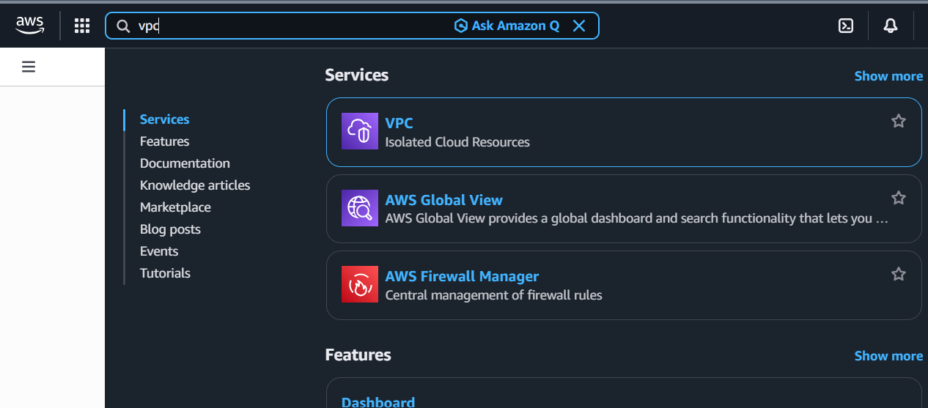

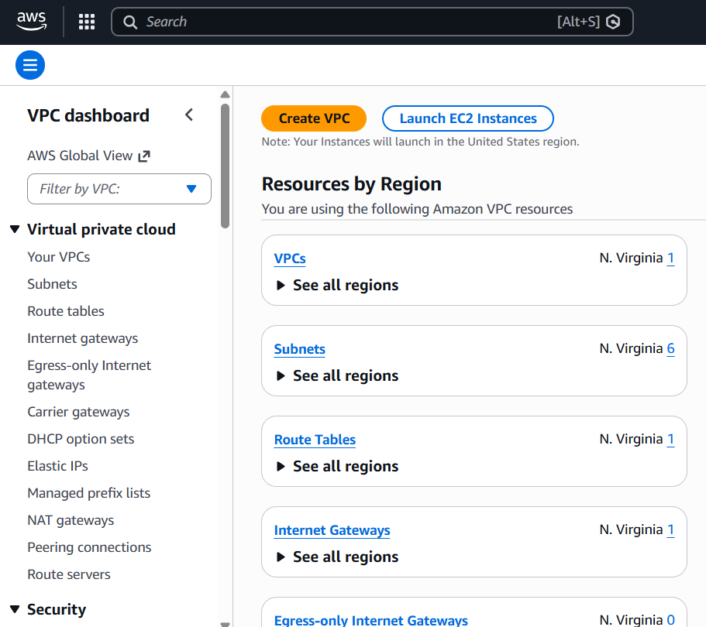
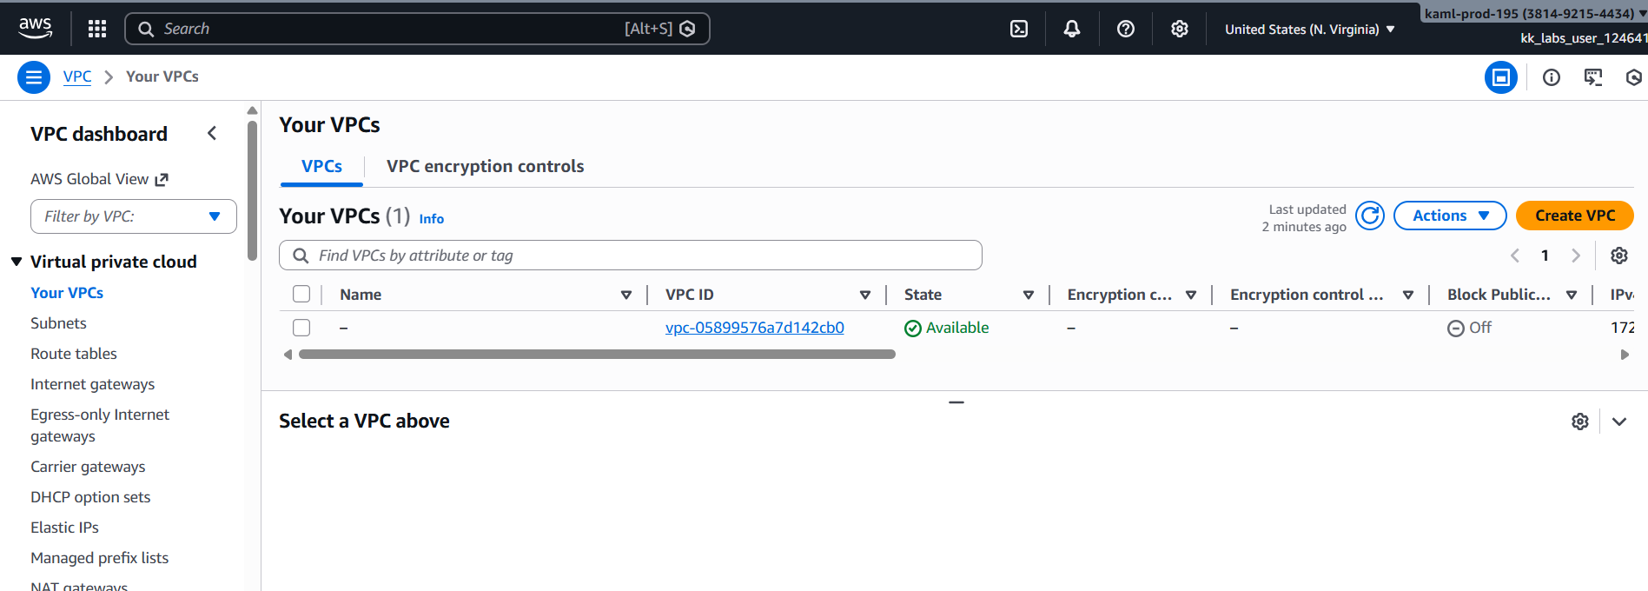
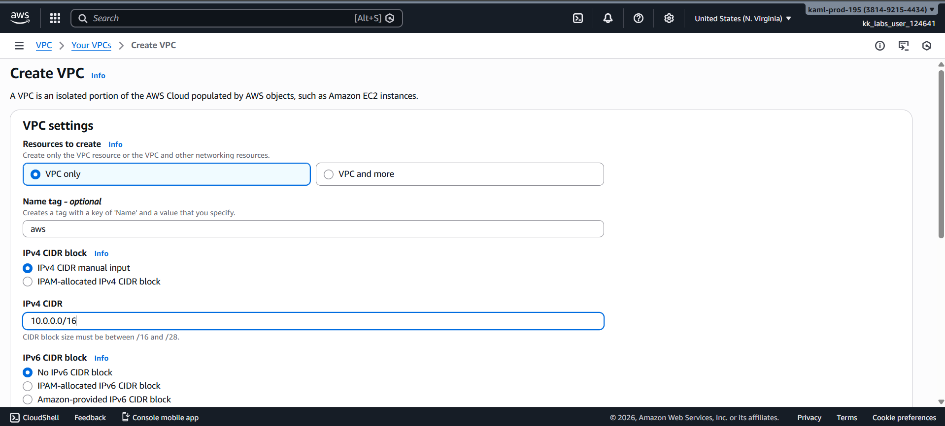

Step 2: Subnets Design

Subnet Name Purpose Required IPs CIDR
Admin Bastion / Ops ~256 10.0.62.0/24
Edge Ingress / LB ~512 10.0.60.0/23
Web Web Tier ~1024 10.0.56.0/22
App App Tier ~2048 10.0.48.0/21
Platform Containers / Tools ~4,096 10.0.32.0/20
Shared Large Internal Services ~8192 10.0.0.0/19

Go to VPC → Subnets → Create subnet
Select VPC = Enterprise-VPC
Enter subnet details (Name, CIDR, AZ)
Click Create subnet
Repeat for all 6 subnets
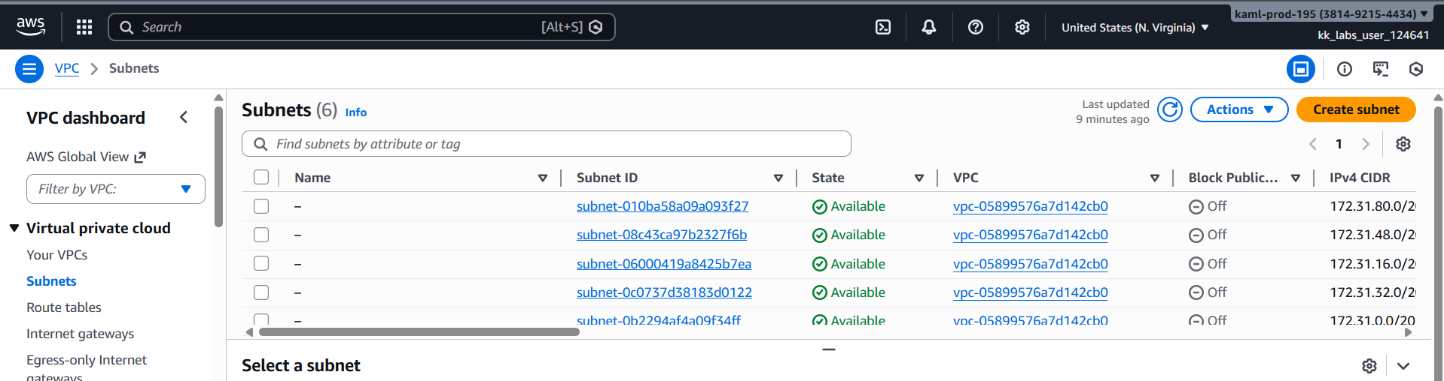
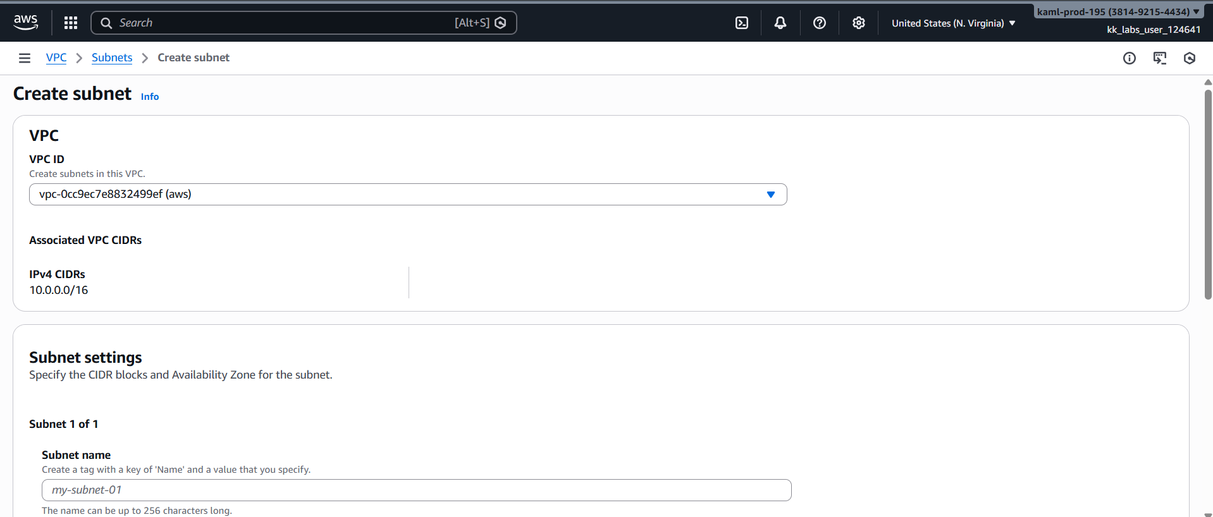

Step 3: Creating IGW & Attaching VPC

1. Go to VPC → Internet Gateways → Create internet gateway
2. Name: Enterprise-IGW
3. Click Create
4. Select IGW → Actions → Attach to VPC → Enterprise-VPC
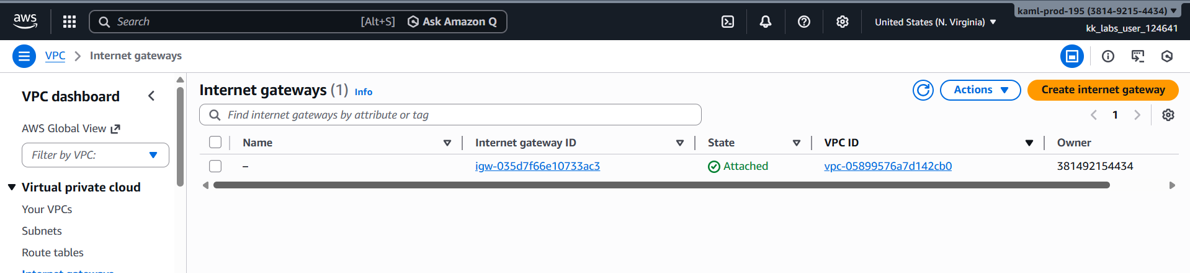
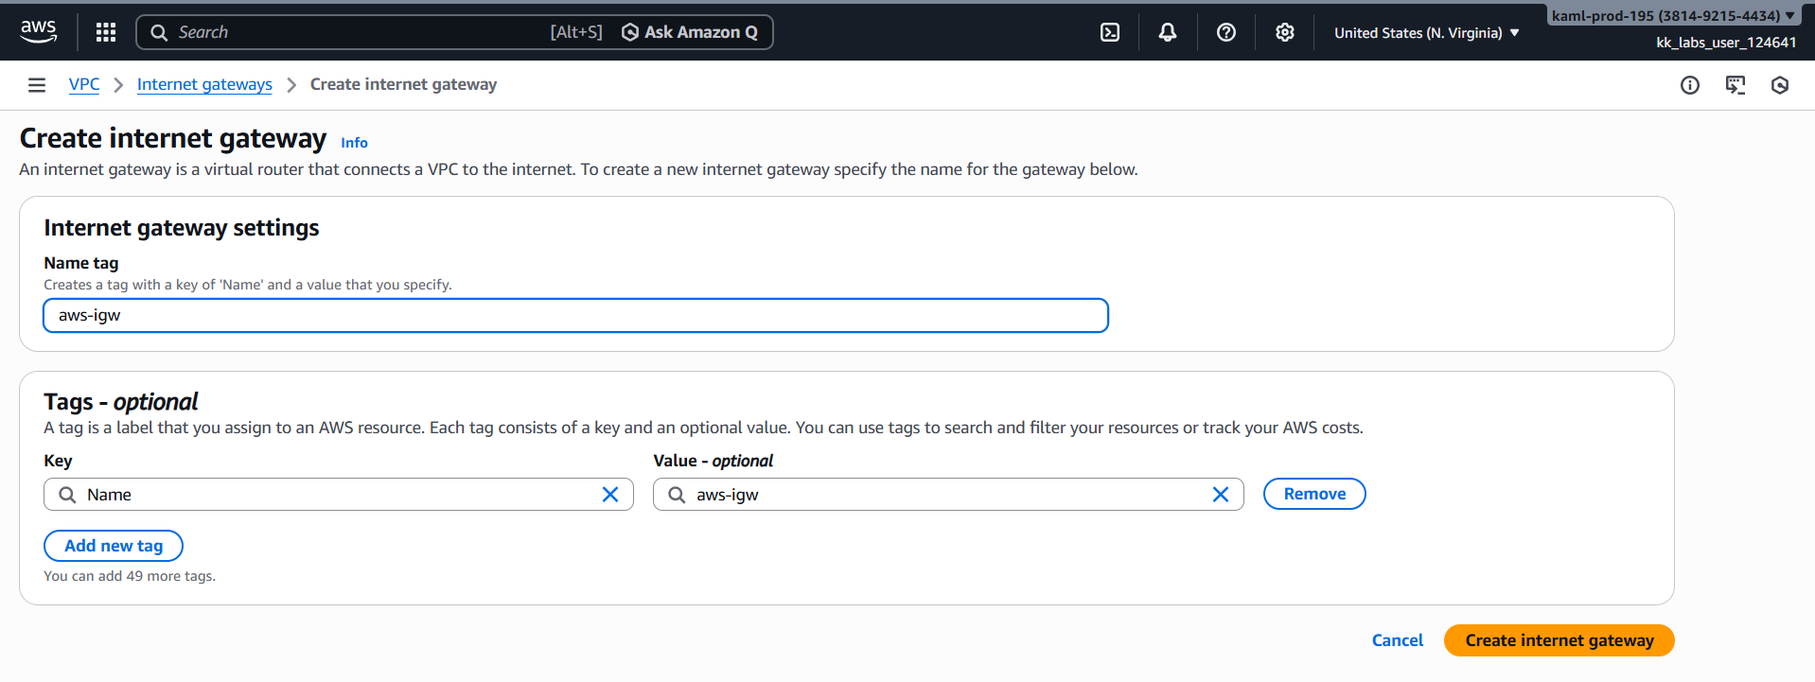
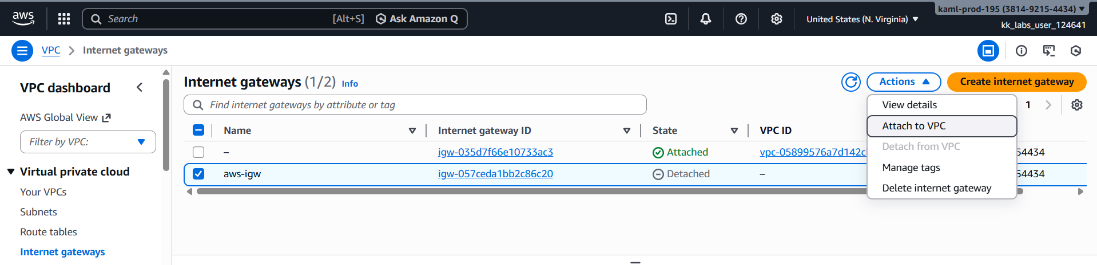
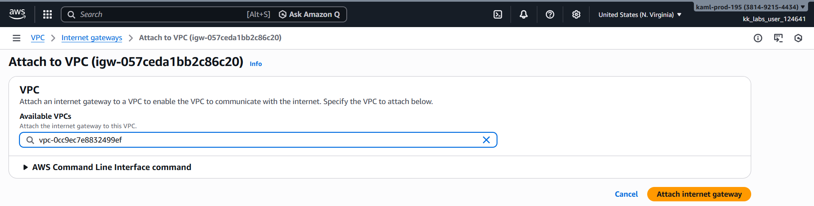

Step 4: Create Route Tables
4a. Public Route Table (Admin + Edge)
1. Go to VPC → Route Tables → Create route table
2. Name: Public-RT
3. VPC: Enterprise-VPC
4. Click Create
5. Select Public-RT → Routes → Edit routes → Add route
o Destination: 0.0.0.0/0
o Target: IGW → Enterprise-IGW
6. Keep default local route 10.0.0.0/16

4b. Private Route Table (Web, App, Platform, Shared)
1. Go to Route Tables → Create route table
2. Name: Private-RT
3. VPC: Enterprise-VPC
4. Routes: Only local 10.0.0.0/16
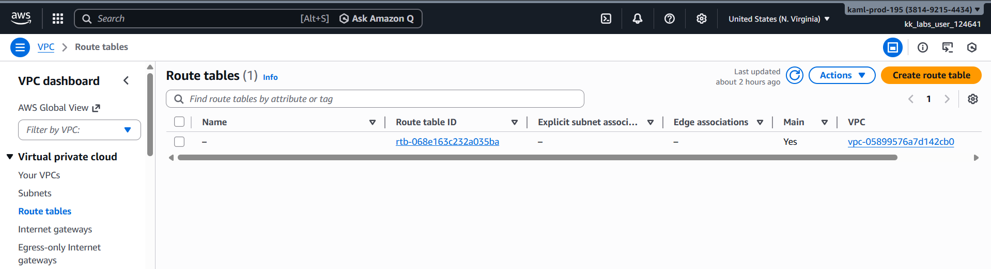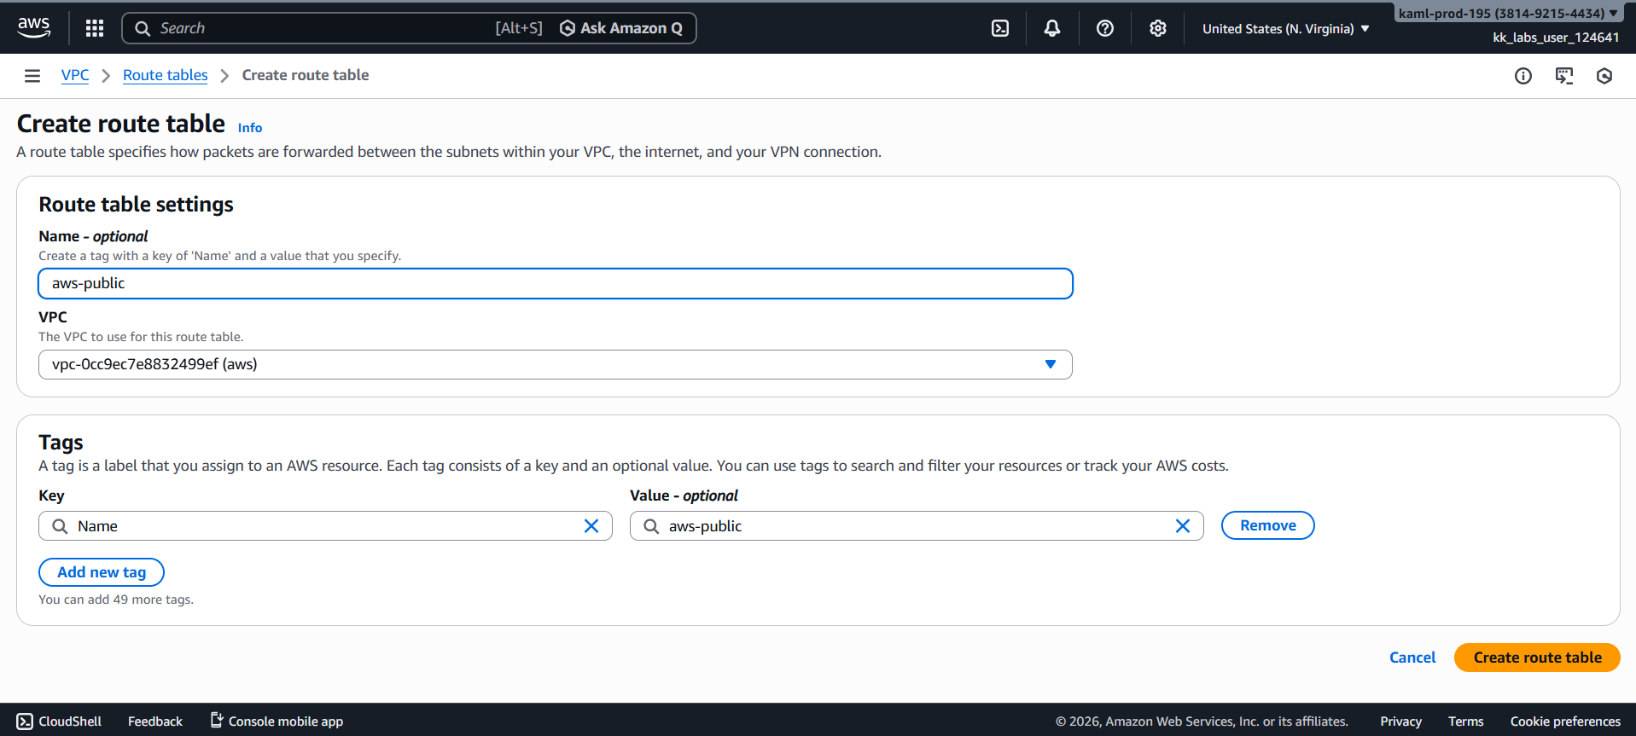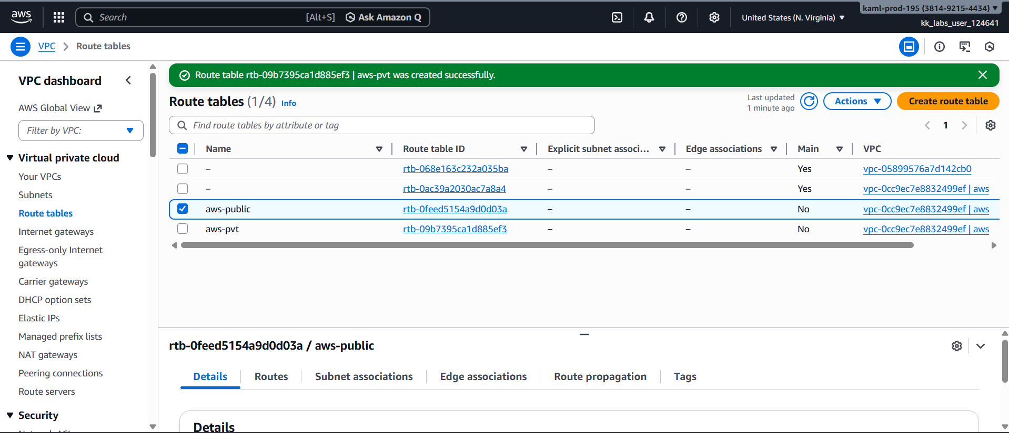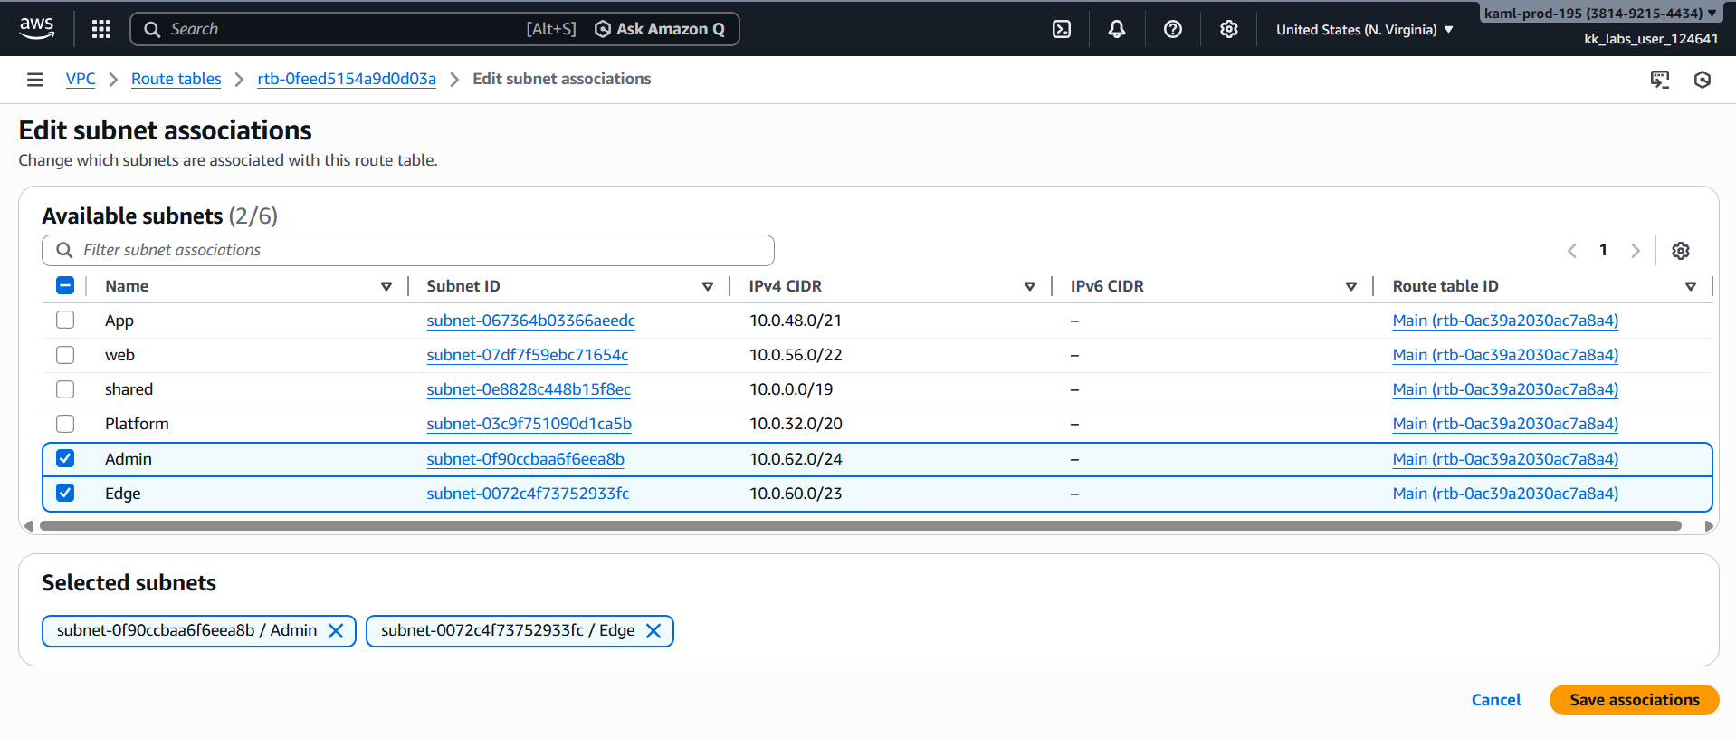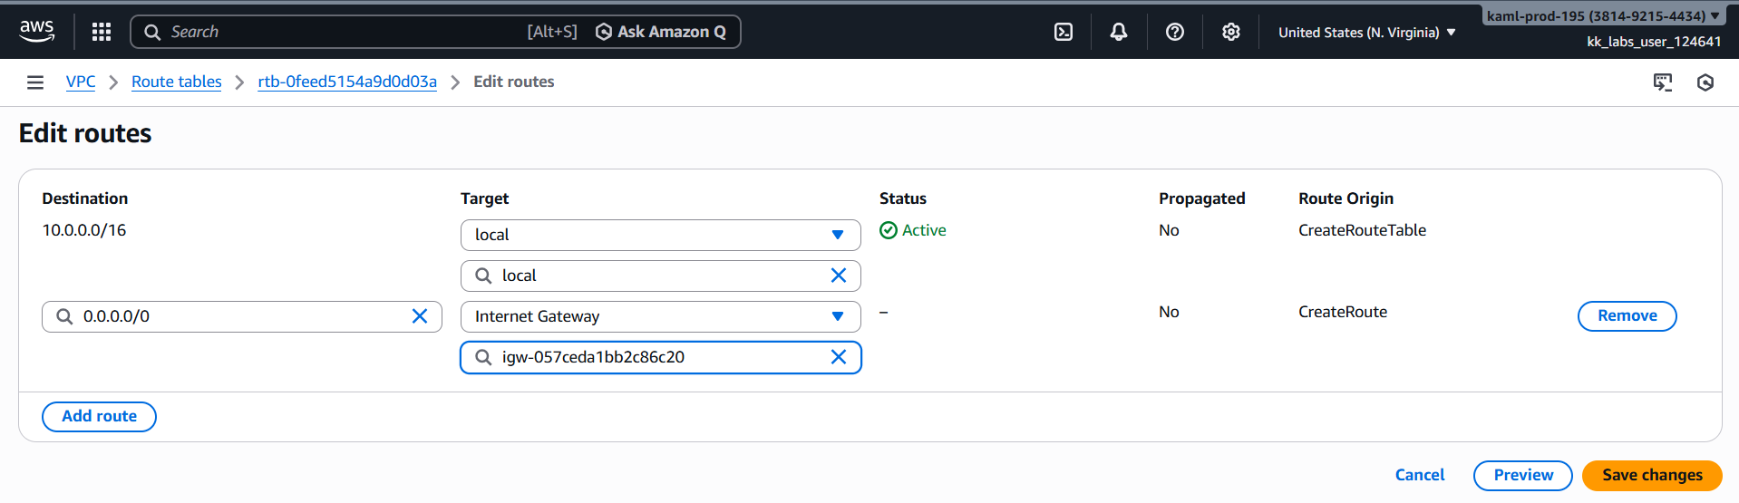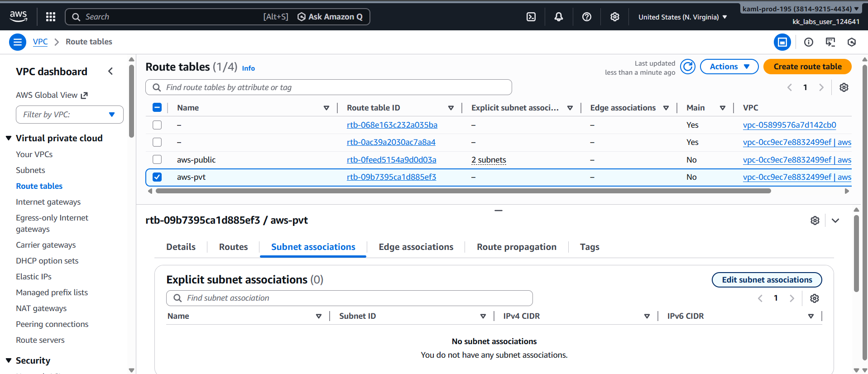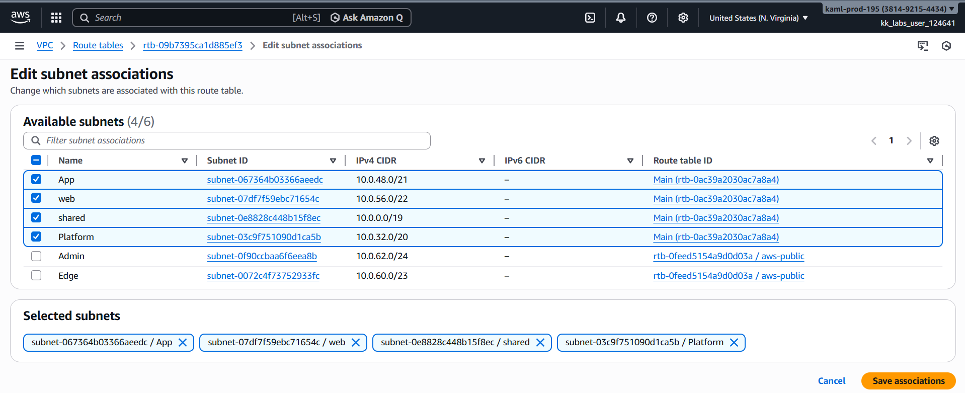

Step 5: Launch EC2 For Testing
Launch Test EC2 Instances
1. Launch 1 EC2 per subnet (use Amazon Linux 2 AMI)
2. Public subnets: assign public IP
3. Private subnets: no public IP
Security Groups: allow ICMP (ping) and SSH for testing
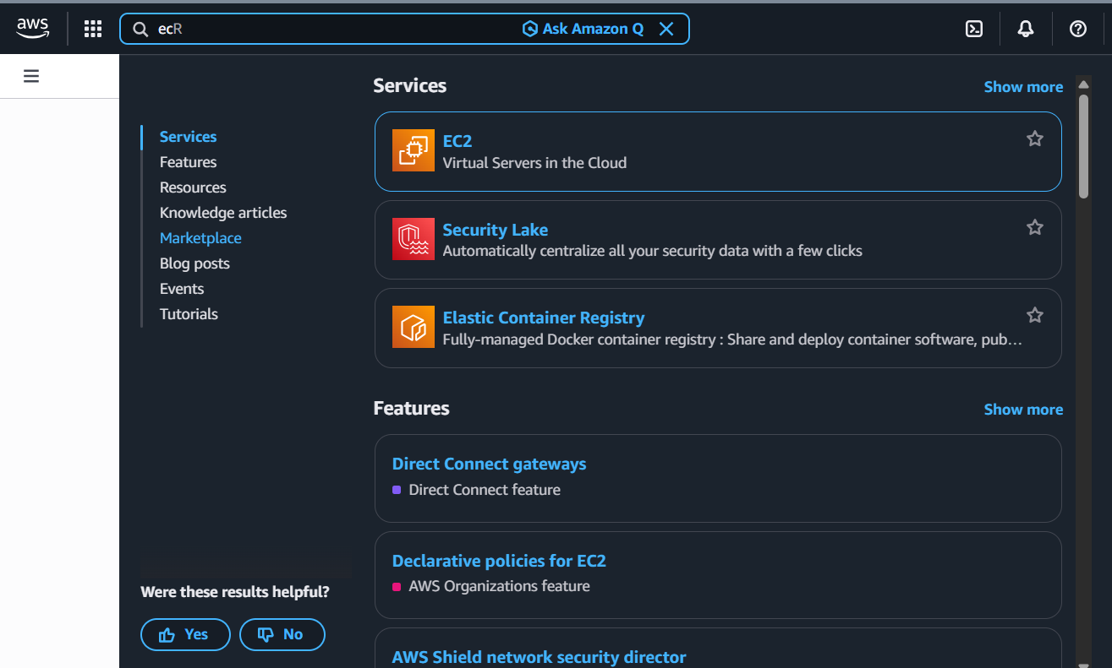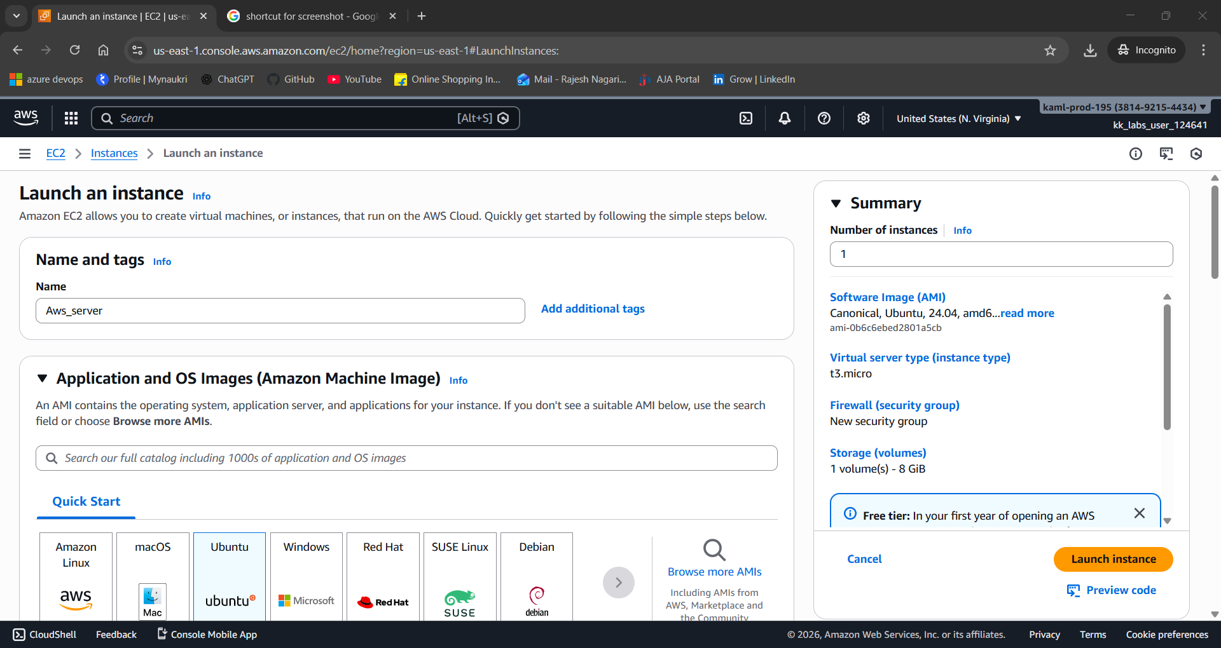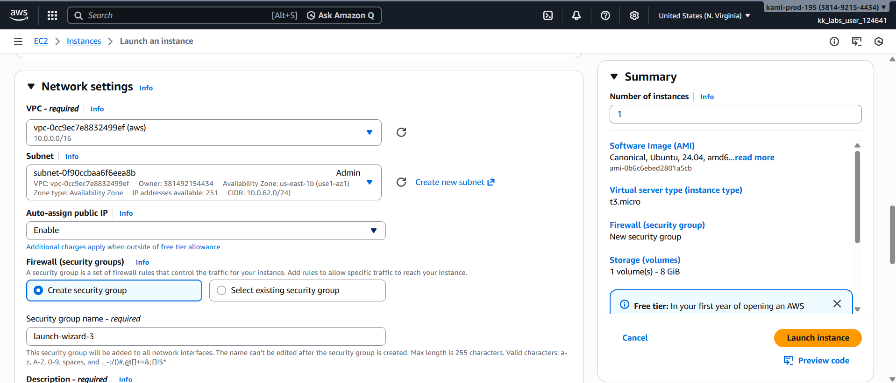
Step 6: Go to the terminal and connect to server for public and private sub-netted servers Testing
